Justin Jaunay

Chad Stone

Nicholas Jurgens

Rameet Sandhu

Santino Milan

Hongni Liu

**Project Phase 4**

Table of Contents

*Part I: Facilities*

*Part II: Transportation*

***Project Planning***

1. **Define the Problem**
   1. Work on both cycle and safety inventory
   2. Design the facilities/transportation network
   3. Implement software framework
   4. Simulate Purga’s supply chain and examine various scenarios using the integrated software
   5. Demand forecasting
   6. Meet with professor
2. **Create a Plan**
   1. **Step 1:** Align and integrate the high-level strategies with the detailed implementations of each driver
      1. **Step 1.1:** Clearly state the intent of the project
      2. **Step 1.2:** Determine the design/development sub-tasks and activities
      3. **Step 1.3:** Create a design/development activity matrix purpose to understand the dependencies between the sub-task
      4. **Step 1.4:** Create a schedule of tasks using a GANTT chart
      5. **Step 1.5:** Identify the “critical path” for the project sing PERT chart
      6. **Step 1.6:** Assign clear roles and responsibilities for each subtasks/activities
3. **Execute the Plan**
   1. **Step 1: Project Plan**
      1. **Step 1.1:** The intent of of the project is to create a smart trash can. Our company name is Purga. The smart trash can sort garbages, recycling, and compost into appropriate bins. The trash can has 5 bins, 1 for garbages, 2 for recycling, 1 for compost and 1 for waste.
      2. **Step 1.2:** Sub-tasks and activities
         1. **A**: Facilities Network
         2. **B**: Transportation network
         3. **C**: Implement software framework
         4. **D**: Simulate SC using the integrated software
      3. **Step 1.3:** Activity Matrix

|  |  |  |  |  |
| --- | --- | --- | --- | --- |
|  | A | B | C | D |
| A | A |  |  |  |
| B |  | B |  |  |
| C | X | X | C |  |
| D | X | X | X | D |

Notation:

X = “depends on”

BxA = subtasks B depends on subtask A

* + 1. **Step 1.4:** Gantt Schedule

|  |  |  |  |
| --- | --- | --- | --- |
| Phase 4 Tasks | Start Date | Due Date | Duration (hours) |
| Facilities  Network | 2/28/17 | 3/14/17 | 8 |
| Transportation Network | 2/28/17 | 3/14/17 | 7 |
| Implement Software Framework | 2/28/17 | 3/14/17 | 2 |
| Simulate SC Using Software | 2/28/17 | 3/14/17 | 2 |

|  |  |
| --- | --- |
| 2/28 3/2 3/4 3/6 3/8 3/10 3/12 3/14 | |
| Facilities  Network |  |
| Transportation Network |  |
| Implement Software Framework |  |
| Simulate SC Using Software |  |

* + 1. **Step 1.5:** Pert Chart



***Part I: Facilities***

1. **Define the Problem:**

In addition to cycle and safety inventory, two important new elements (SCM “drivers”) of your project are designing/implementing Facilities and Transportation Network

**II. Plan the Treatment of the Problem:**

1. **Facilities**

* ***Step 1:*** Determine the strategy for the Facilities driver to be aligned with the SC strategy and the competitive strategy of the firm
* ***Step 2:*** Determine the role, location, and capacity of the facilities
  + Role: What is the purpose of the facility?
  + Location: Where is the facility located?
  + Capacity: How big should the facility be?
  + Capacitated Plant Location Model: Optimization problem to help determine location, capacity, and other SC variable to minimize total cost while maximizing efficiency
  + Given/Notation:
    - i - denotes plants or facilities (i = 1,2,...n)
    - n - total number of plants
    - j - denotes the regions of demand (j = 1,2,...n)
    - m - total number of demand regions
    - For each plant i,
      * fi = fixed annual cost of operating the plan
      * yi = decision variable for selecting the plant location (If yi = 1, have a plant at location. If yi = 0, don’t have a plant at location)
      * ki = capacity of plant i (units/year)
* For each demand region j,
  + Dj = annual demand for region j
* Between a plant i, and a demand region j, we have a flow of supply
  + Xij = quantity of items shipped from plant i to the demand region j
  + cij = total cost (material cost + manufacturing cost + holding cost….) per item
* Total Annual Cost, C = (fixed cost of operating the plants + variable cost for flow of supply between plants and demand regions)
  + C = fiYi + Xijcij → Equation 1
* Constraints:

1. Demand side constraint (for any demand region j, (j = 1, 2,...m))

* X1j + X2j + ... Xnj Dj
* Xij Dj  → Equation 2

1. Supply side constraint:

* YiKi X1j + X2j + ... Xnj
* YiKi - Xij 0 → Equation 3
* Objective: Minimize the total annual cost C given by equation 1 subject to the constraints given by equations 2, 3, and 4
* Approach:

1. Set up the objective functions (equations) in EXCEL
2. Use Solver to determine
   1. The decision variables Yi
   2. The flows Xij (i = 1, 2,...n), (j = 1, 2,...m)

* ***Step 3***: Determine the actual location of each facility using a “Gravity Location” model
* ***Step 4:*** Optimize the entire (total) Supply Chain Network

**B. Transportation Network**

* ***Step 1:*** Which mode of transportation should be used?
  + Choose the mode (air, water …) that minimizes total cost.Total Cost = Transportation Cost + Inventory Holding Cost
  + (Inventory = Cycle + Safety + In-Transit)
  + Create a table of options with mode, lot size, transportation cost, cycle inventory cost, safety inventory cost, In-transit inventory cost, total inventory cost, total cost.
* ***Step 2:*** Should inventory be aggregated spatially?
  + Select the scenario that minimizes the total cost, or provides the best balance between efficiency and responsiveness.
* ***Step 3:*** Should orders be aggregated in time (temporal)
  + Create a table of options.

**III. Execute the plan:**

**Objective:** Our product is only going to be sold within the United States and targeted towards environmental friendly states. Our goal is to keep cost low so we stay highly efficient as a company.

**Table of Miles Between Warehouse Cities & Demanded Cities**

|  |  |  |  |  |  |  |  |
| --- | --- | --- | --- | --- | --- | --- | --- |
| **City** | **Montpelier, VT** | **Santa Cruz, CA** | **Santa Fe, NM** | **Madison, WI** | **Seattle, WA** | **Portland, OR** | **Orlando, Florida** |
| **Temple, TX** | *1910* | *1739* | *663* | *1157* | *2103* | *2029* | *1135* |
| **Chicago, IL** | *949* | *2190* | *1263* | *141* | *2043* | *2119* | *1157* |
| **Sacramento, CA** | *2995* | *147* | *1141* | *2019* | *752* | *580* | *2816* |
| **Raleigh, NC** | *815* | *2800* | *1748* | *958* | *2848* | *2863* | *595* |
| **Nashua, NH** | *147* | *3178* | *2240* | *1148* | *3065* | *3108* | *1306* |

*The figure above shows the miles in between each warehouse city to demanded city. The highlighted boxes show the optimal city to transport to for each of the cities based off the distance.*

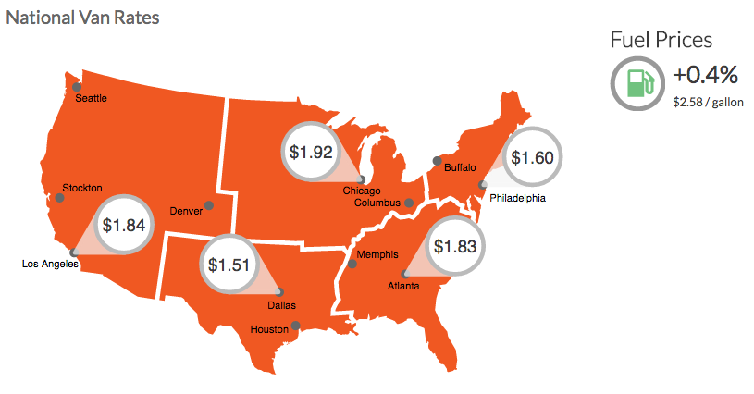

https://www.dat.com/resources/trendlines/van/national-rates

*In the figure above we see the truck rates for each region by price per mile and then an addition 4% for fuel which is 2.58/gallon. Each of our warehouses fall into one of the following regions above and will transport the product to demanded cities within that region as well.*

**Miles From Warehouse City to Demanded City * Price/Mile**

|  |  |  |  |  |  |  |  |
| --- | --- | --- | --- | --- | --- | --- | --- |
| **City** | **Montpelier, VT** | **Santa Cruz, CA** | **Santa Fe, NM** | **Madison, WI** | **Seattle, WA** | **Portland, OR** | **Orlando, Florida** |
| **Temple, TX** | *2884* | *2626* | *1041* | *1747* | *3176* | *3063* | *1714* |
| **Chicago, IL** | *1822* | *4205* | *2425* | *280* | *3923* | *4068* | *2221* |
| **Sacramento, CA** | *5511* | *281* | *2099* | *3715* | *1439* | *1110* | *5181* |
| **Raleigh, NC** | *1491* | *5124* | *3199* | *1753* | *5212* | *5239* | *1132* |
| **Nashua, NH** | *244* | *5085* | *3584* | *1837* | *4904* | *4973* | *2090* |
| **Total Cost per Trip** |  |  |  |  |  |  | ***5,527*** |

*The table above shows the cost of each trip from warehouse city to demanded city and the total cost is* ***$5,527***

**Links to warehouses:**

***Chicago, Illinois***

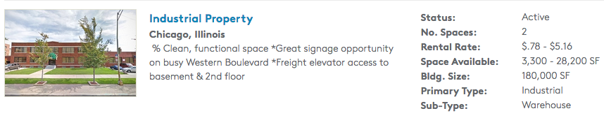

* Chicago, IL: <http://www.loopnet.com/Listing/20202653/5335-S-Western-Blvd-Chicago-IL/>

***Sacramento, California***

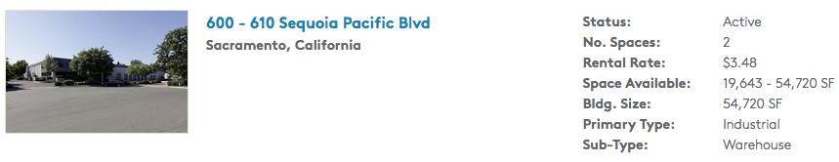

* Sacramento, CA: <http://www.loopnet.com/Listing/18343989/600-610-Sequoia-Pacific-Blvd-Sacramento-CA/>

***Nashua, New Hampshire***

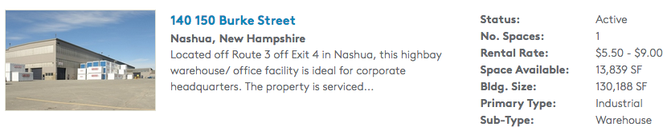

* Nashua, NH: <http://www.loopnet.com/Listing/14390502/160-164-Burke-St-Nashua-NH/>

***Raleigh, North Carolina***

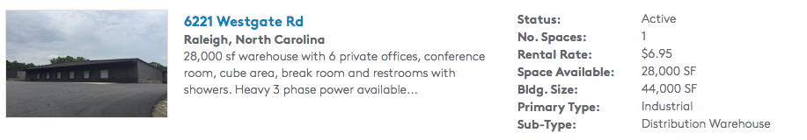

* Raleigh, NC

<http://www.loopnet.com/Listing/19855144/6221-Westgate-Rd-Raleigh-NC/>

***Temple, Texas***

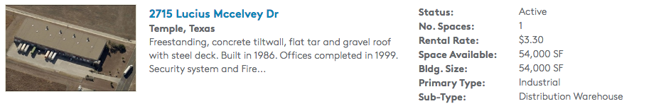

* Temple, TX

<http://www.loopnet.com/Listing/20032033/2715-Lucius-Mccelvey-Dr-Temple-TX/>

We picked these locations because they were low costing area’s and they were close enough to demanded cities. We picked a warehouse within each region (South, Upper East Coast, Lower East Coast, West, Upper Midwest). We wanted to keep cost low so our company would stay highly efficient and we minimized the amount of warehouses we want to just 5 locations to stay highly efficient since our product isn't a necessity and consumers won’t be demanding our product frequently we thought it’d be best to have less warehouses meaning less inventory because we do not expect our product to be bought so frequently. We also decided to rent capital (facilities) because we have high IDU and since we are company just starting out we would want to see the growth and success of our product before proceeding and investing in buying a warehouse that we may not be able to afford. We also picked these demanded cities because referring back to Phase III in TIM 105 our targeted population were those states that were environmentally friendly and would therefore be interested in buying our eco-friendly product.

**Table of Cost Per Facility**

|  |  |  |  |
| --- | --- | --- | --- |
| **Warehouse City** | **Price per Sq/Ft per Month ($)** | **Sq/Ft** | **Price per Year ($)** |
| **Temple, TX** | *.28* | *54,000* | *181,440* |
| **Raleigh, NC** | *.58* | *28,000* | *194,600* |
| **Sacramento, CA** | *.29* | *35,000* | *121,800* |
| **Chicago, IL** | *0.06* | *28,200* | *22,020* |
| **Nashua, NH** | *.46* | *63,263* | *375,446* |
| **Total** |  |  | ***895,306*** |

This table shows the various prices per square feet per month and the allocated amount of space for each warehouse along with the cost per year. The total cost is going to be about **$895,306** for all of our facilities combined.

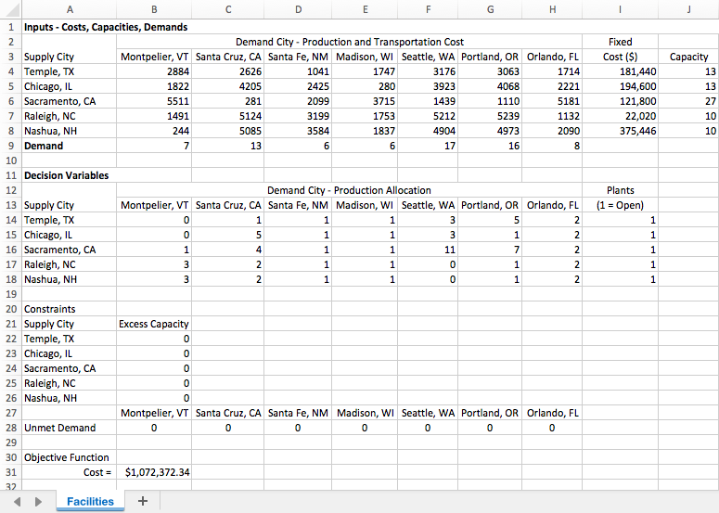

The above excel spreadsheet shows the supply chain facilities/network optimization for Purga’s Smart Trash Can

* Cells B4:H8 provides the variable production, inventory, and transportation cost of producing in one region
* Cells B9:H9 shows the annual demand for each of the regions
* Cells I4:I8 shows the fixed costs for each supply city which can be found in the work prior to the spreadsheet
* Cells J4:J8 lists the capacity of each supply city which was derived from the amount of capacity available for each supply warehouse. This information can also be found above.
* Cells B14:H18 correspond to the decision variables xij and determine the amount produced in a supply region and shipped to a demand region. Initially, all the decision variables are set to be 0
* Cells B22:B26 contain the capacity constraints and cells B28:H28 contain the demand constraints
* The objective function is shown in cell B31 and measures the total fixed cost plus the variable cost of operating the network which resulted in being $1,072,372.

After analyzing the spreadsheet above, one will notice that Purga will have plants open in each of our supply cities. The following supply cities will transport supplies/goods to the corresponding demand cities

* Temple → Santa Cruz, Santa Fe, Madison, Seattle, Portland, Orlando
* Chicago → Santa Cruz, Santa Fe, Madison, Seattle, Portland, Orlando
* Sacramento → Montpelier, Santa Cruz, Santa Fe, Madison, Seattle, Portland, Orlando
* Raleigh → Montpelier, Santa Cruz, Santa Fe, Madison, Portland, Orlando
* Nashua → Montpelier, Santa Cruz, Santa Fe, Madison, Portland, Orlando

**IV. Draw conclusions:**

Overall, we were able to implement process and design for calculations regarding facilities. We began by locating available warehouses in the cheapest places among the different regions across the country. Then we located the demand cities by looking for the “greenest” cities where the demand for our product will be at it’s highest. Then we implemented the excel spreadsheet process of ultimately calculating the objective function cost which was $1,072,372

**V. Check your work:**

For this problem, we used the material from the textbook to double-check our work and ensure that we had a working system before we put in data from our actual project. Although we ran into some trouble embedding solver into the program, we overcame this obstacle and completed the problem thoroughly

**VI. Learn and generalize:**

This problem involved using solver in Excel which helped our group learn this useful tool which can be very helpful in the future by speeding up processes. By using the system we made, we were able to identify the best facilities set-up that would be beneficial and cost efficient for our company

***Part II: Transportation***

1. **Define the Problem:**

* In addition to cycle and safety inventory, two important new elements (SCM “drivers”) of your project are designing/implementing Facilities and Transportation Network

1. **Plan the Treatment of the Problem:**

* Problem: Design the transportation network connecting suppliers to end-customers with the objective of minimizing total cost
* Process:
  + **Step 1:** Which mode of transportation should be used?
    - Choose the mode (air, water, land…) that minimizes total cost
    - Total cost = transportation cost + inventory holding cost
      * Inventory = cycle + safety + in-transit
    - Create a table of options with mode, lot size, transportation cost, cycle inventory cost, safety inventory cost, in-transit cost, total inventory cost, total cost
  + **Step 2:** Should inventory be aggregated spatially?
    - Yes, explore options for spatial aggregation of inbound transportation. Select the scenario that minimizes total cost, or provides the best balance between efficiency and responsiveness
  + **Step 3:** Should orders be aggregated in time?
    - Explore options for temporal aggregation. Aggregation of orders in time will reduce transportation of order in time will reduce transportation cost (i.e. increase efficiency) but will reduce responsiveness (because of delay in shipping items to the customers). Create a table of options

1. **Execute the Problem:**

* **Step 1:** Mode of transportation
  + Given: Using the information gathered from the cycle and safety inventory section of Phase III
    - Lot Size:
      * Took the average of the optimal lot size for each of the components that make up the smart trash can and got 9,939 units
        + Rail lot size = 9,939*2 (rail has the ability to make large shipments at a cheaper price than air)
        + Air lot size = 9,939*1.5 (air is the most expensive mode of transportation but can ship large orders)
        + Truck lot size = 9,939 (the most limited mode of transportation)
    - Cycle Inventory = Q/2
    - Safety Inventory = L/2 days of demand
      * L (rail) = 3
      * L (air/truck) = 2
      * 16,561 Smart Trash Cans are purchased each year
      * ss (rail) = [(3+1)/2]*(16,561/365) = $822
    - In-Transit Inventory = 16,561(L/365)
    - Total Inventory Cost = (Cycle + Safety + In-Transit)*Holding cost
      * Holding cost = $500*0.25 = 125
    - Total Cost = Total Inventory Cost + Annual Transportation Cost
      * Annual Transportation Cost = 16,561*0.65 = 65,000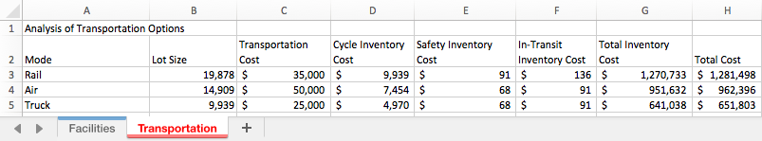
* The method of transportation that minimizes cost is to use trucks and transport over land
* **Step 2:** Spatially Aggregated Inventory
* It’s important to explore options for spatial aggregation of inbound transportation. This will allow us to select the scenario that minimizes the total cost, or provides the best balance between efficiency and responsiveness
* Given: Using the information gathered from the cycle and safety inventory section of Phase III
  + The cycle and safety inventory values were found back in Phase III
  + Total inventory is cycle and safety inventory added up
* After completing the above calculations for the three different scenarios, it appears that it would be best to restock more frequently in order to lower inventory holding costs. Option B which is a customer order system would increase transportation costs too much and decrease efficiency substantially. 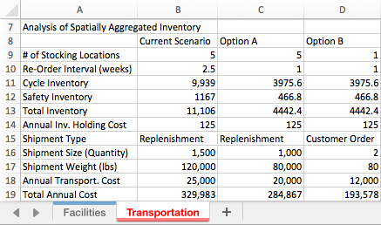
* **Step 3:** Temporal Aggregated Orders
* Aggregation of orders in time will overall reduce transportation costs (i.e. increase efficiency) but will reduce responsiveness due to the delay in shipping items to the customers. Below is a table of different response options which will ultimately lead us to to discover if aggregating orders over time will reduce the cost by comparing two-day, three-day, and four-day response times.
* Given: Using the information gathered from the cycle and safety inventory section of Phase III
  + Demand was found in Phase III after calculating cycle and safety inventory
  + Quantity shipped:
    - Two-day response = 9939/12 (the average optimal lot size for each component of the smart trash can/12 months of the year)
    - Three-day response = (Two-day response)*2
    - Four-day response = (Two-day response)*3
  + Cost:
    - Two-day response = 4502/12 (the average shipping cost for each component of the smart trash can/12 months of the year)
    - Three-day response = (Two-day response)*1.5
    - Four-day response = (Two-day response)*2
* After completing the above table, Purga will pursue a transportation network using trucks to carry our product as well as our supplies to each location. Furthermore, having a system of distribution warehouses would be good to reduce transportation costs while having an additional customer order system would increase responsiveness for the system as a whole. Lastly, we will implement a slight aggregation over time, increasing the response time to three days rather than two to reduce costs while maintaining a good amount of responsiveness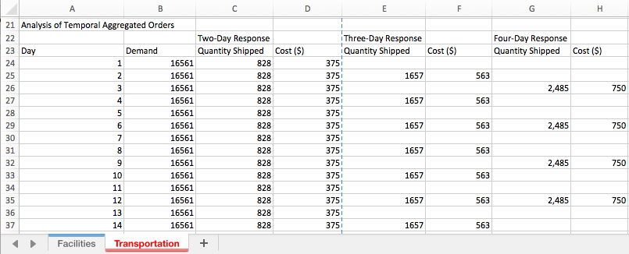
* **Step 4:** SC Network showing movement of inventory using selected mode of transportation
  + The arrows symbolize the transportation of goods and supplies from one destination to another using the selected mode of transportation which would be to use trucks in order to save the most amount of money

1. **Draw Conclusions:**

Overall, the transportation section was a three step process to compare different modes of transportation, spatially aggregated inventory, and different response times. This lead us to find that using trucks as our mode of transportation would be the most cost effective option. Additionally, having a higher rate of restock of inventory will also increase efficiency. Finally, we found that using a little bit of aggregation over time will increase response time while simultaneously being cost effective.

1. **Check Your Work:**

In this problem, we used the material in Chapter 13 of the textbook as well as the lecture notes in order to fully complete this problem and double-check our work along the way. Our results also logically make sense so we’re confident that we have the correct results

1. **Learn and Generalize:**

This problem is very useful for weighing out our different options of transportation. Altogether, this problem provides a great understanding of the step by step process of selecting the appropriate mode of transportation and how to maximize efficiency while minimizing cost.